**StatsLibrary User Manual**

A collection of Java based statistical functions.

Cachary Tolentino

CSCI-3327

**Table of Contents**

**Software Description3**

Detailed Description3.1

System Requirements3.2

**Installation Guide4**

**Class Overview6**

**Software Description**

A collection of Java based statistical functions.

**Detailed Description**

In the StatsLibrary class you can find a multitude of different statistical functions that can be used to calculate various formulas for a given set of inputs. You can find functions such as factorial, poissonDistribution, etc.... More functions can be found in the **Class Overview** section.

**System Requirements**

* A working device, primarily a desktop or laptop
* An IDE (ex: VSCode, Eclipse, etc…)
* Java JDK (Ver. 17 & up) & JRE (SE 17 & up)

**Installation Guide**

To begin using StatsLibrary, you will need to download two files. One is “StatsLibrary.java” and the other is “TestStatsLibrary.java” (optional).

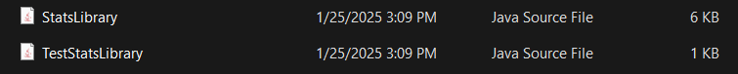

After downloading the files, simply move the files to the folder containing your project. Once done, you can open your preferred IDE (for this example we will be using VSCode). Then you can open the folder or the file itself within your IDE.

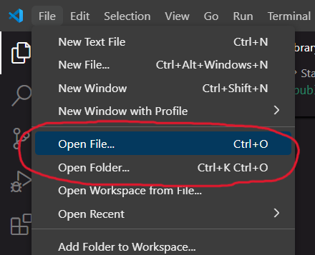

If you opened the folder containing the files then it should look similar to the image below.

If you only imported the StatsLibrary file then you can simply start using the class within your own personal project. Otherwise, if you also imported the TestStatsLibrary, then you can open that file and run it.

The result will be displayed on the console, unless there are graphical displays being run.

**Class Overview**

**factorial Function**

The factorial function calculates the factorial value of a given integer value. It takes in an int value as the number to find the factorial value. It returns a BigInteger value of the factorial. This is primarily used as a helper function for combination and permutation functions.

**poissonDistribution Function**

The poissonDistribution function will calculate the poissonDistribution value based on the given lambda and y value. The function will return this value as of type double.

**poissonVariance Function**

The poissonVariance function will calculate the poissonDistribution’s variance based on the given lambda value. The function will simply return the lambda which is of type double.

**poissonStandardDeviation Function**

The poissonStandardDeviation function will calculate the poissonDistribution’s standard deviation based on the given lambda value. The function will simply return the lambda which is of type double.

**tchebysheff Function**

The tchebysheff function will calculate the tchebysheff value based on the given k value and if it is greater than or equal to (or opposite*)*. The function will simply return the value based on the equation below.